Research on Elderly TV Programs Based on the Characteristics of the Times and the Demands of the Elderly

DanYa Liu, DongHun Lee

Dept of Image Contents
Graduate School of Dong-Seo University
Busan, South Korea
453485595@qq.com
papamac@hanmail.net

Abstract

Television, as a most exposed media and an important supplier of spiritual products for the elderly, should play a positive role in alleviating the aging process. However, in China, there are very few TV programs that are based on the potential demands of the elderly. It is precisely in this context that the topic of this paper has more practical significance.
This article mainly investigates the characteristics of the times and the demands of contemporary elderly people. Finally, around the demands of the elderly, a few representative elderly TV programs are chosen to carry out specific analysis, in order to provide some research basis and evidence for planning and producing TV programs that are more in line with the demands of Chinese elderly group.

Keywords-Aging; elderly TV program; family separation; loss of authority; information enclosure

I. Introduction

Aging of population has become an unavoidable problem in the world. With the intensification of aging, how to provide a good spiritual and cultural environment for the elderly; and how to build a "positive aging" society have become a concern of the country and society.
In the daily life of the elderly, TV is the media they contact for the longest time. Therefore, in-depth theoretical study on the elderly TV programs has great significance for promoting the construction of harmonious elderly society.
After reviewing a large number of literatures, this paper summarizes that the elderly TV programs are studied in the foreign journals from the aspects of the relationship between TV media and elderly, the TV ratings data and the satisfaction surveys on the elderly. The representative papers include: Robert W. Kubey's Television and Aging: Past, Present, and Future; Nancy Ziegler's How older persons are portrayed in television advertising: Implications for educators; John Bell's In Search of a Discourse on Aging: The Elderly on Television; The Relationship between Watching of TV Health Programs and Practice of Health Behaviors among the Elderly published in 2011 by Hyun-Jung Lee, Jae-Young Park; and A Study on the Image of Elderly People in TV News and Educational Programs published in 2014 by KIm Suk and Park Joo-Yeun.
Despite such a severe aging trend, there are scant theoretical researches concerning TV programs for Chinese elderly in the Chinese academia. The studies are focused on three aspects: the importance of elderly programs; existing issues; and how to improve the quality of programs. The representative works are: Xia Yunyan's Discussion on the planning of elderly TV programs in 2001; Li Jianhua's Aging era calls for TV channels for the elderly in 2007; Zheng Chengfa's Status and development strategy of elderly TV programs in 2014; Deficiencies and improvements of elderly TV programs published by Wang Huimin in January, 2015; etc.
This paper carries out research around the characteristics of the times and the demands of contemporary elderly based on the Chinese elderly TV programs, which is a direction and attempt of deepening the theoretical research. It not only helps the Chinese TV industry better adapt to the elderly audience and better meet the elderly People's viewing demands and spiritual and cultural life, but also provides some theoretical reference and ideas for the academia.

II. Theoretical background

To actively cope with the aging of population, a series of laws and policies including the Revised Law on Protection of Elderly Rights, the Twelfth Five-Year Plan on the Aging Undertakings in China, etc. all point out that the media need to assume the social responsibilities of meeting the elderly people's spiritual and cultural demands and comforting their hearts, which should give full play to the functions of disseminating information, providing entertainment and coordinating social relations to establish a platform for communication between all sectors of society, thereby meeting the spiritual and cultural demands of the elderly and promoting the harmonious development of society.
The more targeted the TV programs for elderly in terms of arrangement and production, the better they can meet the spiritual demands of the elderly and enhance their joy of life, which can even solve their problems. Therefore, the introduction of elderly TV programs undoubtedly reflects the society's understanding of the elderly group and spiritual care, which plays an important role in building a harmonious society.
In this paper, the TV programs tailored to the elderly audience by the provincial-level or above TV stations in China are analyzed statistically, which finds that there are only 13 programs targeted for the elderly, such as "Sunset Glow", "Wonderful Old Friends", "Parents around China" and "Maple Leave are Red".
The above survey on the status quo of elderly TV programs in China is just the foundation of study, while the characteristics of the times and the demands of contemporary elderly are the focus of theoretical research. Only by understanding the characteristics of the times and the potential demands of the contemporary Chinese elderly, can we produce TV programs that are really suitable for the elderly group.

III. TV program demands of Chinese elderly

A. Characteristics of the times of contemporary Chinese Elderly

We can summarize two factors that influence the characteristics of the times as social factors and cultural factors. It is under the joint influence of these two factors that the contemporary Chinese elderly show a series of characteristics of the times, such as: family separation, loss of family authority and information enclosure.

A.a. Family separation

Influenced by the 'filial' culture, family-based caring is the dominant mode of eldercare in China, where the offspring plays a very important role in the later life of elderly. However, the implementation of 'reform and opening up' and 'one-child' policies has led to an increased number of empty nest families, so that the elderly people live alone, suffering spiritual loneliness. The traditional Chinese culture, on the contrary, advocates independent personality and values spiritual life. Therefore, family separation has become an important factor affecting the spiritual life of the elderly. 'Family separation' prompts the elderly people eager to acquire knowledge about entertainment and living. Just as Wang Xihua and Zhou Huafa mentioned in the Correlation between quality of life, sense of loneliness and subjective well-being among the elderly1, the "empty nest phenomenon in China increased the pension and mental health risks of elderly people, who are eager to exchange and communicate with others to ease the spiritual loneliness. Meanwhile, they also hope to get knowledge about living, in order to better their solitary life.

A.b. Loss of family authority

The family ethical ideas of 'benevolence & filial piety' uphold the supremacy of parents. However, after the establishment of socialist system, the feudal patriarchy has gradually lost its role, with family relations developing gradually towards democracy, equality and freedom. In addition, with the implementation of 'one-child' policy, the families with single child have been dominant, and the intergenerational center of family has tended to younger age. These "lead to the 'preference of child to elderly' and 'valuing of upbringing over eldercare' phenomena"². Regarding the 'loss of family authority' problem, Ma Lina, Tang Zhe et al. stated in the Effects of Familial Factors on Mental Health of Elderly People in Beijing that "the change in the authoritative position of elderly people let them feel the indifference and desolation of family members. To get the attention and respect of the family, the elderly group usually pays special attention to major domestic and foreign news events, in order to make contributions to the state and nation and to prove their value."³ This also reflects the elderly people's demands for love and respect.

A.c. Information enclosure

The Commentaries on Yi reads that "The man of honor will strive constantly for self-improvement" and that "Work hard all day long, keep pace with the times". Influenced by such a progressive outlook on life, the Chinese elderly people have the desire to continue to seek knowledge. However, the "Cultural Revolution" has led to low cultural and educational level of contemporary elderly people, coupled with the increasingly weak ability to learn, many technological products and new things are daunting to them, which limits their access to information. The 'information enclosure' problem is also the reflection of elderly people's demands for acquiring information on life and enriching knowledge. For example, Zuo Meiyun, Liu Bobo et al. mentioned in the Construction and Application of Information Demand Model for the Elderly that "Chinese elderly people have low level of education. Coupled with slowness of accepting new ideas, they are rather informationally closed. For better living, they have the demands for accessing to information on life and enriching knowledge."⁴
In summary, the three characteristics of the times of the contemporary Chinese elderly people, i.e. family separation, loss of family authority and information enclosure, reflect that they have demands in three aspects: love and respect, life service and entertainment, as shown in Fig. 1:
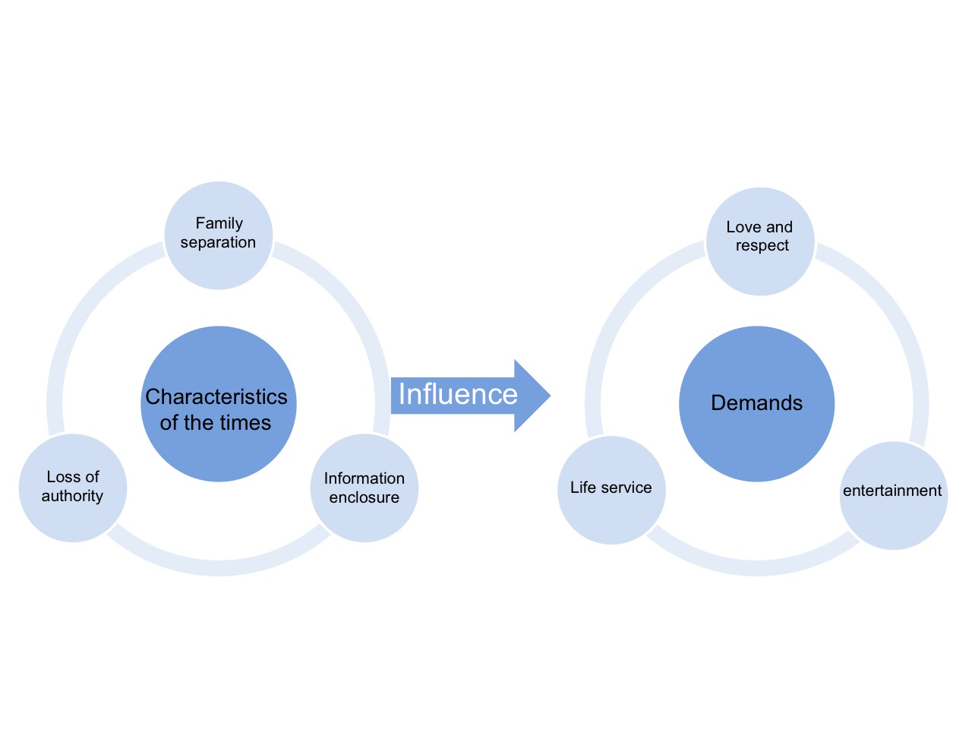
[Fig. 1] TV viewing demands of Chinese elderly people
IV. Case analysis of Chinese elderly TV programs

This chapter analyzes in depth the design intention, effect of elderly TV programs in China and the satisfaction degree of elderly group's demands through case studies.

A. Reflection of entertainment needs

Taking the 'Funny Life' broadcast in 2016 by the "Wonderful Old Friends" as an example, this program invites older-generation comedians to talk about their apprenticeship days in the form of interviews. The narrative process is combined with singing and artistic performance, so that the audience can enjoy themselves.
Themed by the traditional Chinese opera that is favored by the elderly group, the program presents the familiar films, familiar faces, familiar music and familiar scenes to the elderly audience via on-site interviews with the older-generation opera artists. Such a program is apt to strike a chord among elderly group and let them recall memories and find tranquility. The opera singing and artistic performance part uses positive and happy emotional appeal instead of negative, pessimistic moods to help elderly group overcome the loneliness and silence in their later life, which meets the elderly people's demands for getting entertainment to ease the spiritual loneliness.

B. Reflection of demands for love and respect

Each episode of "Wonderful Old Friends" has a dating section, which helps the elderly people choose objects of their affection through the exchange with each other and the one-on-one in-depth interviews by the host, so as to care about the love life of elderly groups. The topics like 'Eighty-year-old mother sues her son', 'Meddlesome Luo Guanzhang' and 'Love affair' broadcast by "Sunset Glow" in 2016, as well as 'Seventy-year-old man's wedding trip' and 'Home with quadruplets' broadcast by "Parents around China" in 2016 convey the society's respect and care for the elderly group from the perspectives of realization of personal values, affirmation of elderly authority, filial piety, etc.
The topics of the programs are set up targeting the issues in the elderly society like the separation of family and the loss of authority in family, which not only reflect the society's understanding and caring for the feelings of elderly, but also meet the elderly people's needs for love. Concerning the selection of themes, the news figures and news events are used to discuss the filial piety, eldercare, education and value realization based on the topics and events of elderly group's concern, so as to help them access to more information, which conveys the society's respect for the elderly people and affirmation of their values.

C. Reflection of life service demands

Among China's existing TV programs for the elderly, "Wonderful Old Friends", "Sunset Glow" and "Maple Leaves are Red" all provide services to the elderly groups targeting their demands for acquiring knowledge about life and health, in order to help them live a better life.
Among these programs, the topic 'Drama artist's reminiscence of wonderful life' broadcast by "Wonderful Old Friends" in 2016 invited the elderly group's favorite theater artists to share funny stories during travel and talk about the significance of travelling; recommend the most suitable way of travelling for the elderly people, and specify the expenses and shortcomings, in order to provide inspiration for the audience and encourage the elderly people to be delighted in travelling. The episode 'Healthcare regimes for the elderly' broadcast by "Sunset Glow" in 2016 provided healthcare knowledge to the elderly group with the longevity experience of two longevous elders as the main line. The professional elderly healthcare program "Maple Leaves are Red" invites experts in each episode to explain the health knowledge and correct the wrong knowledge, which introduce health care, medical knowledge and life tips to the elderly audience.

V. Conclusion

All of the Chinese elderly TV programs surveyed are arranged and designed targeting the demands of elderly people, which meet the elderly group's needs for recreation, living, as well as love and respect.
During their arrangement and production, the elderly TV programs should first study and analyze the characteristics of the times of the elderly group, and dig deeper into the potential demands hidden under the characteristics of the times, so as to carry out the program design around the needs of the elderly. Such a design idea can better meet the spiritual needs of the elderly, and promote the formation of a harmonious society.

Acknowledgment

This research was supported by BK21plus Level-up Project for Marine design team in Dongseo University

References

[1] Yang Guijun, "On the positioning of television programs - CCTV [sunset red] program as an example, 2014
- Zhang Xue'e, "the characteristics of China's population aging and countermeasures", market forum, 2013
- Zhang Ling, "on the media in the aging society in the political responsibility", Tianjin Geshi Times, 2010
- Wang Huimin, "Older TV program deficiencies and improvement methods", News World, 2015
- Lu Wenzhao, "the media exposure of the elderly and the needs of the service", young journalists .2012
- Zhao Wei, "old television program analysis and development strategy", news window, 2013

